Prospectus

Little Acorns

Where big hearts shape little minds.

Listen to children
Interact when appropriate
Teach and learn through play
Trust and respect one another
Learn together
Encourage healthy decisions

Allow children to make choices
Consider and acknowledge the unique needs of children
Observe and plan
Respect and acknowledge the feelings of children and their families
Nurture the development of independence skills
Support and extend development and learning

Welcome to Little Acorns @ Our Lady & St Oswald’s Pre-School
At Little Acorns we provide a safe, stimulating and caring environment. We encourage learning through play and promote increasing independence skills and opportunity to develop personal and social skills with the support of nurturing and experienced staff.
All the staff and management committee at Little Acorns understand how daunting it can be for children and their families when they first start Pre-School. We want to make sure that your child’s first experiences at Little Acorns are exciting and enjoyable.
Please read through the following information about our Pre-School. This will give you all the information you need to support your child during their first sessions with us, and give you some important details that you will need to know.

Key Information to keep handy...

Address: Little Acorns @ Our Lady & St Oswald’s Pre-School, Upper Brook Street, Oswestry, SY11 2TG.
Office telephone number: 01691 676464
Pre-School Mobile number: 07535744196
Email: admin@littleacornspsch.co.uk
Charity number: 1130949
Ofsted number: EY232143
Pre-School Manager: Diana Scott
Meet our staff team...
Diana Scott - Pre-School Manager  Qualifications:  - Children and Young Peoples Workforce Diploma Level 3  - Paediatric First Aid  - Safeguarding and Child Protection  - Food Safety  Designated person for:  - Safeguarding  - Special Educational Needs and Disabilities Co-ordinator  - Behaviour Management | Kelly Boulton – Pre-School Deputy  Qualifications:  - BA Hons Early Childhood Studies  - Early Years Professional Status  - Diploma Teaching in the Lifelong Learning Sector  - Safeguarding and Child Protection  - Paediatric First Aid  Designated person for:  - Safeguarding (deputy)
Faith Francis – Key Person  Qualifications:  - B A Hons Early Year Leadership  - National Nursery Examination Board  - Paediatric First Aid  - Food Safety  - Safeguarding and Child Protection | Clair Griffiths – Key Person  Qualifications:  - Dimploma in Nursery Nursing (NNEB)  - Safeguarding and Child Protection  - Paediatric First Aid  - Food Safety
Emily Scott – Key Person  Qualifications:  - Early Years Educator NVQ 3  - Food Safety  - Safeguarding and Child Protection  - Paediatric First Aid | Becky Jenner – Key Person  Qualifications:  - Early Years Educator NVQ 2  - Safeguarding and Child Protection  - Paediatric First Aid  - Food Safety
The Pre-School is managed by a voluntary parent run management committee.
The committee members can be contacted through the Pre-School. If you would like to join our Pre-School committe you would be very welcome to join one of the termly meetings. Please speak to a member of staff for more details.
Chairperson – Kelly Hughes
Secretary – Ruth Patel
Treasurer – Samantha Martin
Before your child starts
At Little Acorns we work very closely with new families to ensure they have all the information they need to support their child when settling in and starting their first few days at Pre-School.
Come and see us – It is important for parents and carers to have an understanding of what their child will experience in Pre-School. We welcome families to visit us at any time throught the day; and for the children to join in with the others - playing and exploring with the added security of their favourite people close by. If you have not already arranged a visit, please contact the office where we will arrange a date and time to suit you.
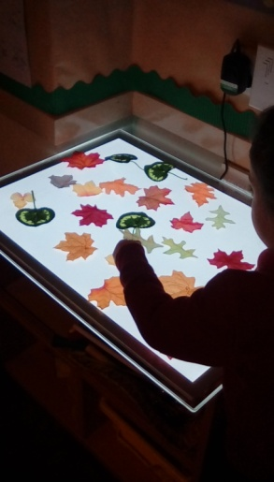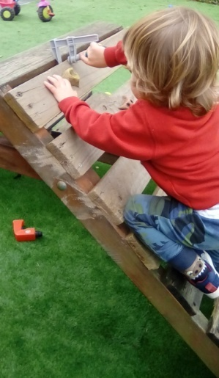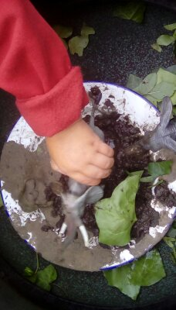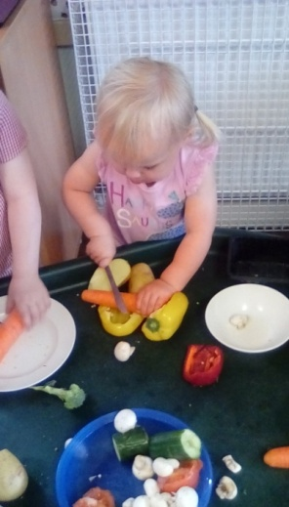

Session times
We are open Monday – Friday 8.00am – 5.00pm during term time.
Sessions available:
8.00 – 9.00 breakfast club
9.00 – 11.30 morning session
11.30 – 12.30 lunch
12.30 – 3.00 afternoon session
3.00 – 5.00 after school club
Fees are charged at £3.50 per hour
15 and 30 hours funding available to all those eligible
Things you need to know...
Clothing  During the day children will have access to the outdoor area in almost every weather. It is importnat that children are dressed appropriately for the weather. This includes wellies, coats, hats, suncream, sunhats, sensible shoes. | Nappies  If your child is still in nappies, they will be changed throughout the session to ensure they stay clean and dry. Please ensure you provide nappies and wipes in your child’s bag. When the time comes to start using the toilet, Pre-School staff will support your child by following your approach at home. Do make sure your child comes with plenty of spare clothes during this time!
Peg, drawer and name card  When your child starts they will be allocated a picture. This will be put onto a name card used for self registration, a drawer and their coat peg. The image will help the children recognise their own place to support independence. | Lunch  For children having lunch with us, they can bring a packed lunch or order a hot meal at a cost of £2.30. Hot lunches must be paid for in advance. A menu is available to view on the information board.
Snacks  A cafe style snack time is available to children during each session. Here they can choose when they have snack, sit with friends and are supported by a member of staff to choose a drink of milk or water and a healthy snack. | Fees  Fees are invoiced at the beginning of every half term. A payment date is given on each invoice. For any invoices not settled by the payment date there will be a 10% late payment charge added. The management committee reserve the right to reduce hours or withdraw a place for any families who do not make payment on time.
Collection  Children will only be allowed to leave with an adult who is known to the staff. In the case of an emergency where someone else may be required to collect your child, you will be asked for a description of the person, and a password which they will be asked for when they arrive.  It is important that you tell us if there is anyone who is NOT allowed to collect your child. | Key person  During your child’s settling in sessions they will be observed, and then allocated a key person according to who they begin to form a famililar bond with.  Your child’s key person will be your first point of contact if you have any queries or concerns regarding your child’s development. They will record observations on your child and upload them to your Tapestry account.

Tapestry
Staff focus on indivdiual children’s progress through an observation and assessment process. This way we are able to plan activities based on your child’s intrests and focus on ways to support their individual development.
This is recorded on their online Learning Journey Profile (Tapestry).
Tapestry is an easy to use online learning journal, which can be accessed on any computer, laptop, tablet or smart phone. We have chosen this company because they are secure and an exciting way of keeping track of your child’s development and their time with us.
Your child’s key person is able to instantly upload photos, videos and observations. You will then be emailed to say that there is something new to look at on your child’s journal. You can also make your own journal entries to tell us what your child has been enjoying/learning outside of Pre-School.

Students
We regularly support students who are on placement as part of their training. Students all have a DBS check before starting their placment and are mentored by staff. Students do not work alone with any children.

Management committee
We are run by a voluntary committee of parents who meet every term to discuss the needs of the Pre-School and organise fundraising events. The management committee are always grateful of new members and are very welcoming to anyone who might want to come along and offer any help. Please speak to a member of staff if you would like to know any more.

School admissions
Children attending this Pre-School are not automatically guaranteed a place at Our Lady and St Oswald’s Ctholic Primary School. Please speak to the school directly if you would like to know more about their admissions policy.

A few requests...
- Please ensure you complete EVERY section of the registration form
- Please speak to us in person if your child has any health, medical or development concerns
- Please inform us of ANY changes to your child’s personal information, including change of address or contact numbers
- Please ensure fees are paid on time
- Please do not send your child in if they are unwell or if they have been given any over the counter medication. If your child has a course of prescribed medication, please speak direcly to a member of staff who will discuss your individual situation.
- Please complete and return any correspondance we send home. We are always grateful for any feedback
- Please let us know in advance if you wish to change your child’s hours
- Please read our information board outside
- Please like our Facebook page. This is where we put any reminders or Pre-School news as well as photos and posts about what the children have been doing.
- Please arrive on time for drop off and collection
- Please wait outside until the session has ended. We will get your child ready for home and send them out as soon as they are ready.
- Please ensure your child is wearing practical and comfortable clothes in all weathers. We get very messy, and sometimes wet! We have a small number of spare wellies, but if your child has everything they need they will be able to participate in all activities on offer.
- Please dont worry if your child doesnt come out at the end of the day with lots of paintings and crafts. It simply means your child was very busy doing something else and did not choose to join in with the craft that day. We offer a child intiated learning enviroment and will never expect children to make something that they havent chosen.
- Please talk to us! It may be about a concern you have, a question about something practical or something that may be worrying your child. By working together it helps us to understand how best we can support individual children. We will always make sure we can find a suitable time to talk.

